Step 7: App IntegrationThere is a command line based application (test.sh) in directory ./app_integration, that consumes the API from Step 1.

We discussed how to deploy the customer API service to Kubernetes in the document 'Step 5: Kubernetes.' After the API service has been successfully deployed, we can use the command-line-based application to consume the API.

The linux script test.sh can be found in directory: ./app_integration

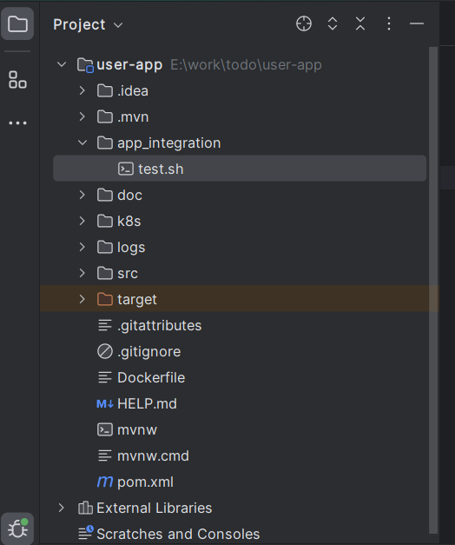

Open a terminal in directory ./app_integration and use the following command lines:

chmod +x ./test.sh

./test.sh

If there is no issue the message looks like this:

